User Guide 15 Lodging a boundary plan application in SPEAR
Purpose of this User Guide
The purpose of this guide is to provide information on how to prepare and submit a boundary plan application in SPEAR for electronic lodgment at Land Use Victoria.
Who should read this guide?
Primary audience: Applicant Contacts
For information: Land Use Victoria
Introduction
SPEAR provides surveyors with an online alternative to the paper lodgment process for boundary plans. Instead of submitting the Approval of Boundary Plan form and payment to Land Use Victoria (LUV) in paper, these can be submitted electronically in SPEAR. This is LUV’s preferred lodgment method.
Accepted methods for the payment of lodgment fees to LUV are:
- Credit card – You will enter your credit card details on the Westpac Secure Payments screen during lodgement.
- Direct Debit (VOTS customer account) – Your account will be automatically debited at the time of lodgment.
15.1 Creating a boundary plan application in SPEAR
For steps to create a boundary plan (BP) application see User Guide 1 – Creating an application in SPEAR.
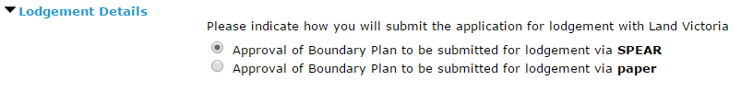
When creating a BP application in SPEAR, the Applicant Contact will need to indicate how the application will be lodged with Land Use Victoria.

15.2 Creating an Approval of Boundary Plan form
Once the BP has been digitally signed, you will be presented with a mandatory action to ‘Create Approval of Boundary Plan’.

Step 1 – Lodged By
This information is prepopulated based on the organisation’s information in SPEAR, however it can be altered if required. The details provided will form the lodging party contact information, which LUV will use if they need to contact you.
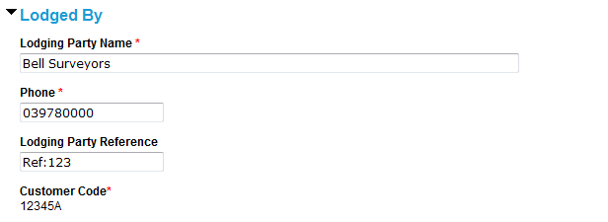

Step 2 – Land
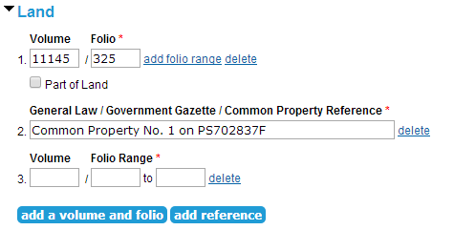
To fulfil the land information requirement, you have the option to add Volume and Folio information. If a title does not exist, the ‘add reference’ option will allow you to provide a General Law, Government Gazette or Common Property reference.

Step 3 – Boundary Plan
The land and surveyor information are prepopulated by SPEAR; however, it can be corrected if required.

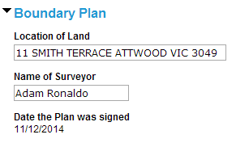

Step 4 – Applicant
The applicant is the person or organisation that requires the application to be registered with LUV. This must be the registered proprietor or incoming purchaser, not the surveyor.
To provide applicant information, click ‘add applicant.’
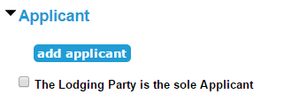

Choose the relevant applicant type and enter the applicant details into the fields provided.
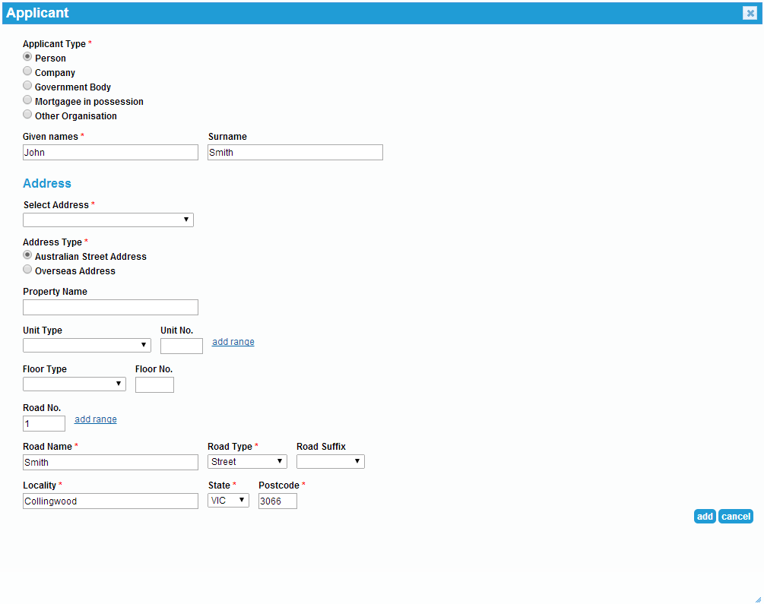

Additional applicants can be added as required by clicking on ‘add applicant’.
NOTE: You can click ‘save’ at any time to save your progress and return later to complete the application.
Once the Approval of Boundary Plan form has been saved, SPEAR will automatically generate the ‘Lodgement Instructions’; both documents must be digitally signed.

15.3 Submit for Pre-Lodgement check
Once you have attached and authenticated the required documents, click on the mandatory action ‘Submit for Pre-Lodgement Check’.
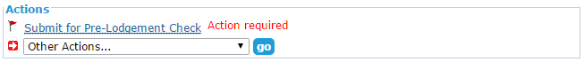

LUV will check the application to ensure it is fit to be lodged. You will be notified by SPEAR when the application is ready to be lodged. A fee estimate will be included in the notification email.

15.4 Lodgement Refusals
Following the Pre-Lodgement Check at LUV, the lodgment will either be accepted or refused. SPEAR will send a notification advising the outcome of the Pre-Lodgement Check. If accepted, you will now have a ‘Pay and Lodge’ action to complete.
If refused, you will see the ‘Submit for Pre-Lodgement Check’ with a View Refusal link next to the action.
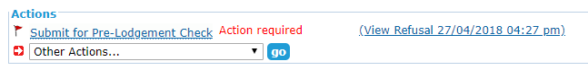

You should view the refusal reasons and modify the application documents accordingly. Once you have made the required amendments, you can complete the ‘Submit for Pre-lodgement Check’ action again.

15.5 Pay and lodge
Click ‘Pay and Lodge’. The lodgment fee will be displayed on screen.
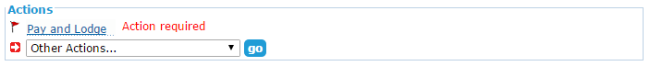

Select your preferred payment method and click ‘pay and lodge’ to submit the lodgment. If you selected to pay by credit card, you will be directed to Westpac Secure Payments to enter your credit card details. A receipt will be available in SPEAR following successful payment.

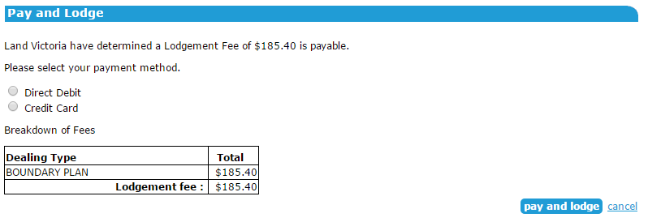

Once the application has been lodged, the status in SPEAR will change to ‘Lodged at Land Use Victoria’ and you will receive an email notification containing the lodgment summary.
Need more information?
Further information on this topic can be found by:
- Visiting the SPEAR website www.spear.land.vic.gov.au/SPEAR
- Contacting the SPEAR Service Desk on 9194 0612 or email spear.info@delwp.vic.gov.au
- Selecting the Help link in the relevant area of the SPEAR system.
- Referring to User Guide 1 – Creating an application in SPEAR.

